|  |  |
| --- | --- |
| **Date** | 30/10/2023 |
| **Team ID** | NM2023TMID01196 |
| **Project Name** | CLIMATE TRACK SMART USING BLOCKCHAIN |

**ADDING METAMASK EXTENSIONS**

**STEP1 :** Open MetaMask by clicking on link : <https://metamask.io/>

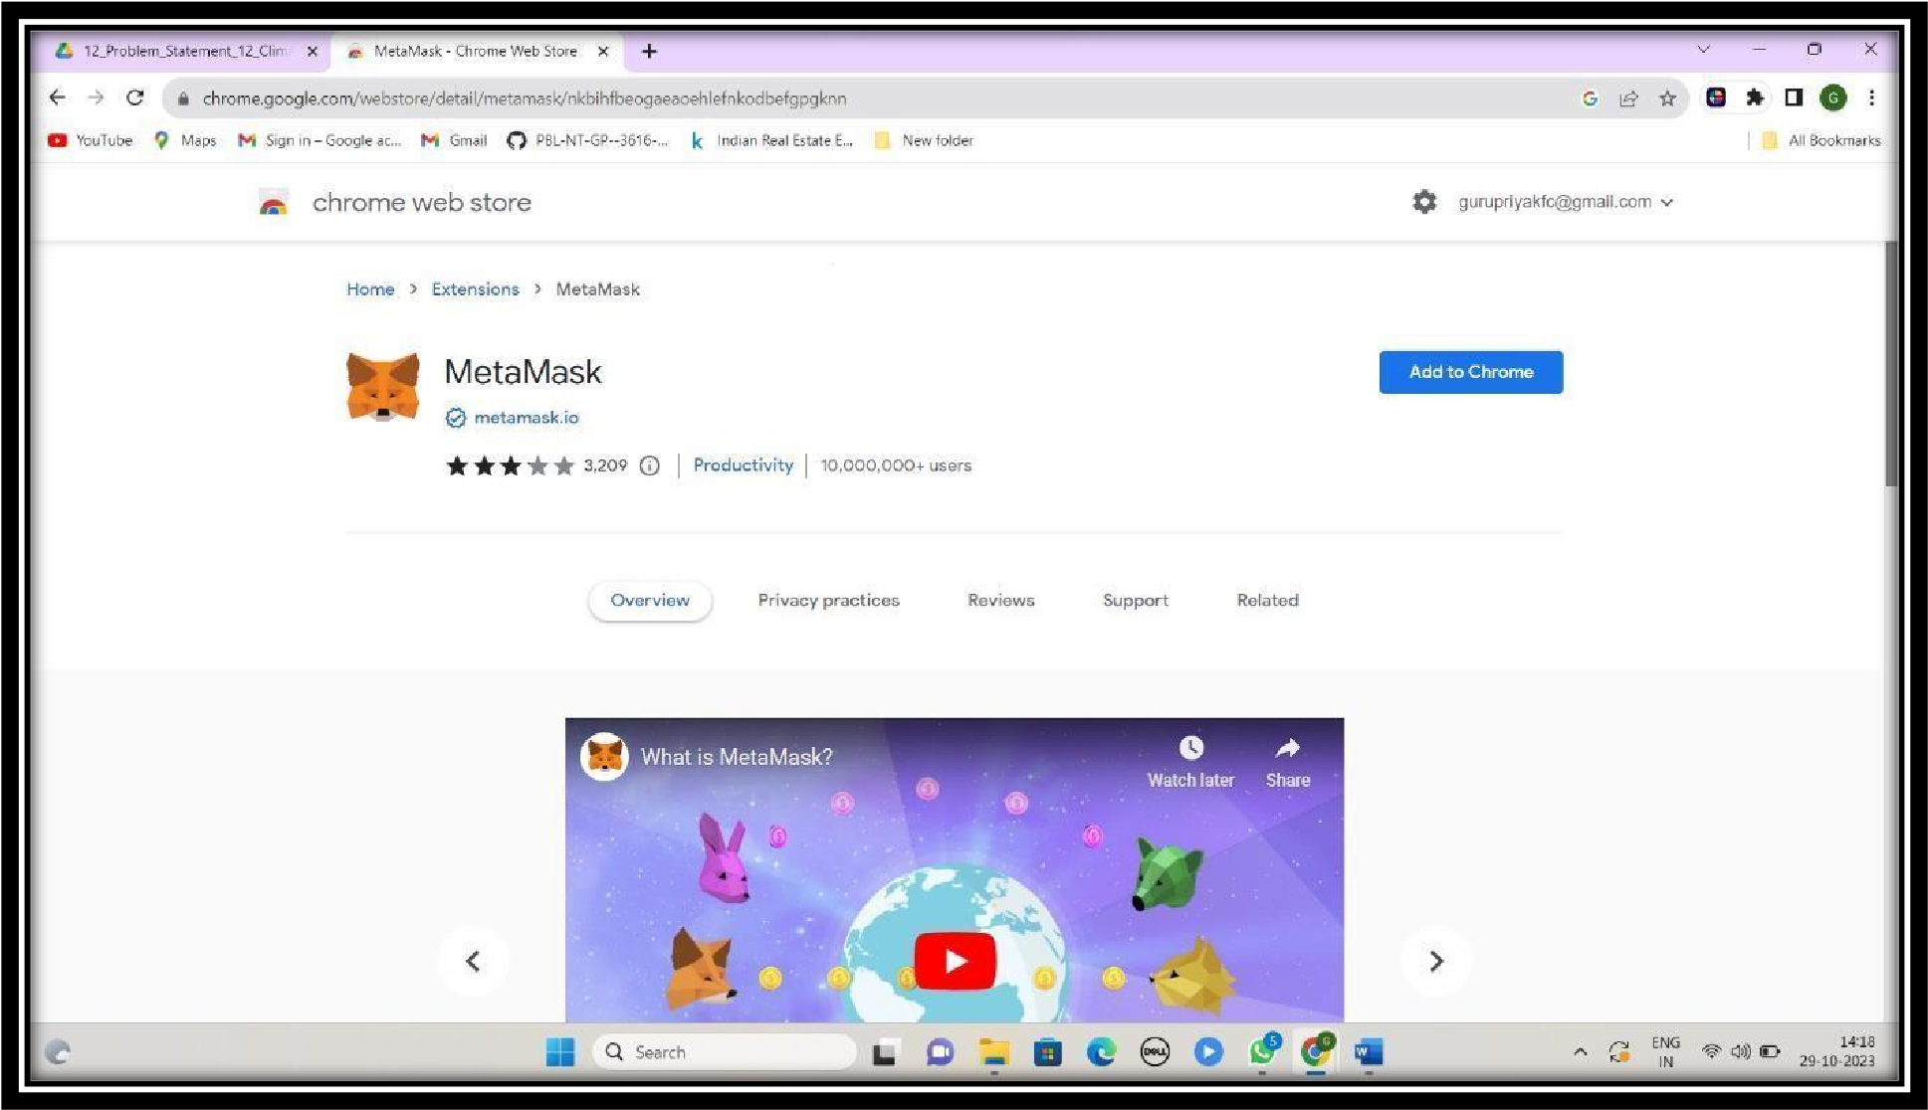

**STEP 2 :** Click on “Get start” and “ I Agree” and download.

**STEP 3:**Either click 'Get' or tap on the name of the app to see more details. Complete the usual App Store download confirmation process.

* Once installed, open the app and follow the prompts to create your wallet.
* Back up your Secret Recovery Phrase somewhere safe and offline!
* Create Password and agree to the document.
* Click on next. And relieve
* Copy paste in notepad “all the letters”
* Click on next
* Arrange all the words in the same order as in the notepad.
* Confirm
* All done

# • Install MetaMask for your browser

|  |  |
| --- | --- |
|  |  |
|  |

• **Click “Add to Add MetaMask Extension and confirm the pop up. Tap Add Extension and Click on get started**

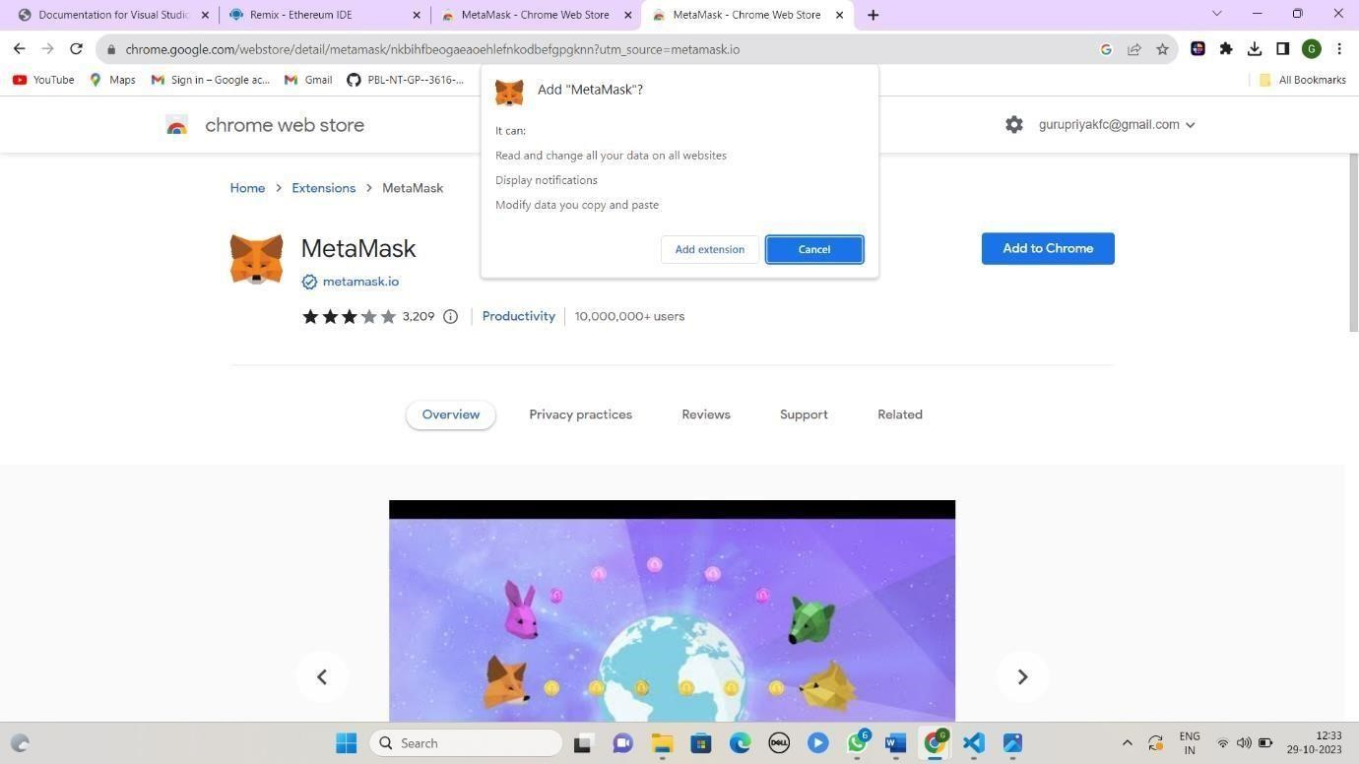

# • Choose Create a Wallet by Clicking on “I Agree”

•

**Click on Create to set up password**

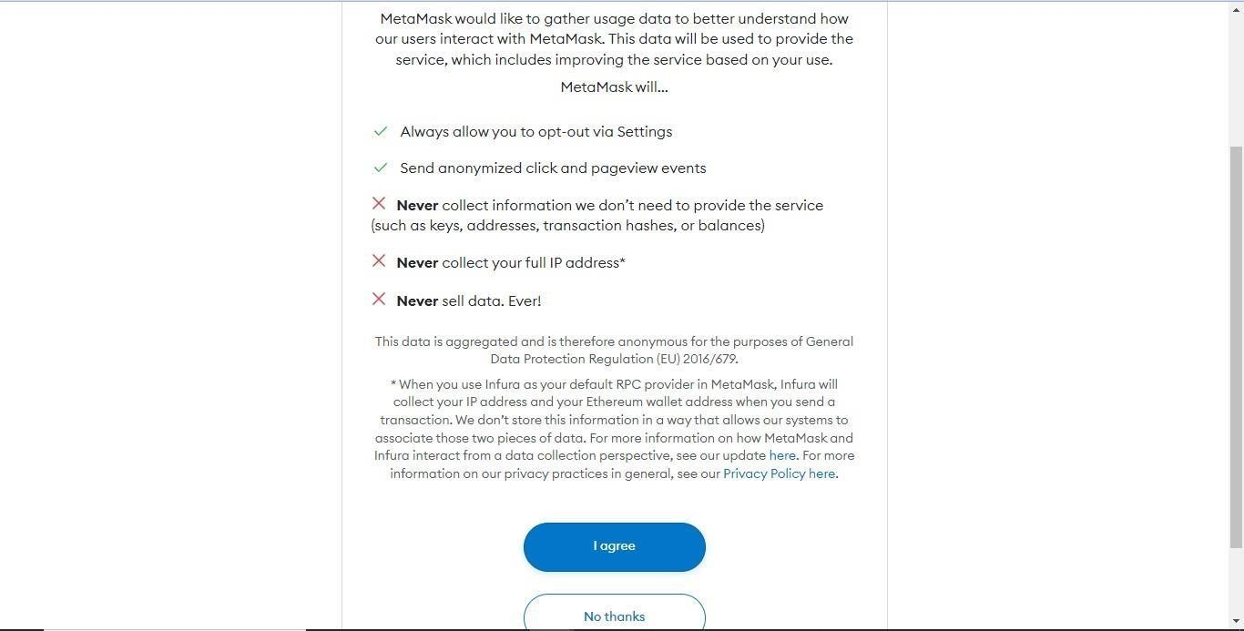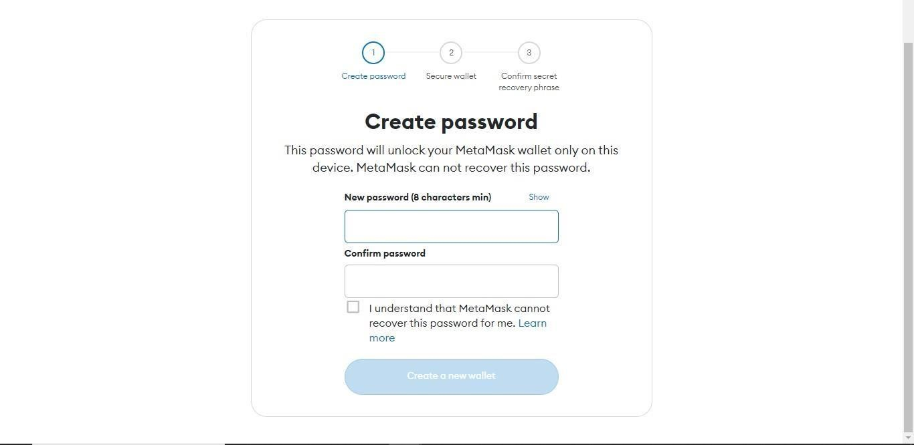

•



**Click on Next**

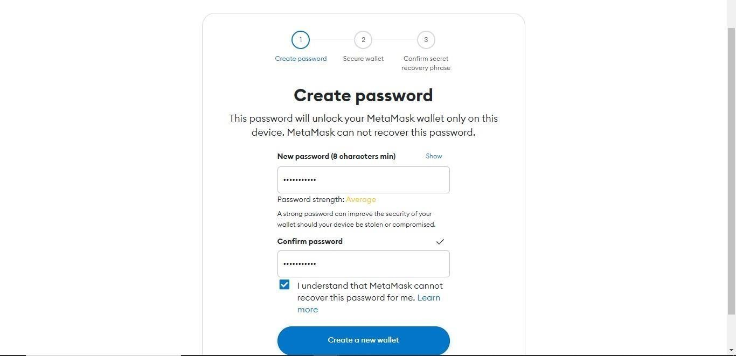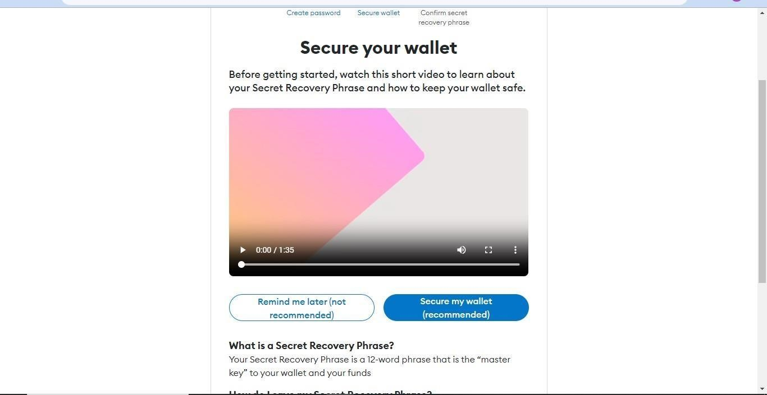

* **IMPORTANT! Tap Click Here to Reveal Secret Words**
* **Memorize this phase. Write and store it Safely**

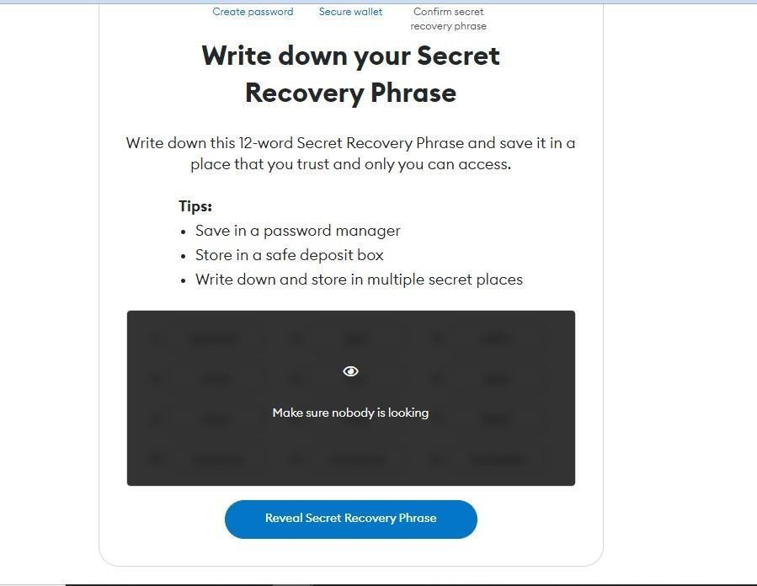

* **Confirm your secret Recovery Phrase by Selecting each phrase in order**
* **Click on confirm to complete the setup**

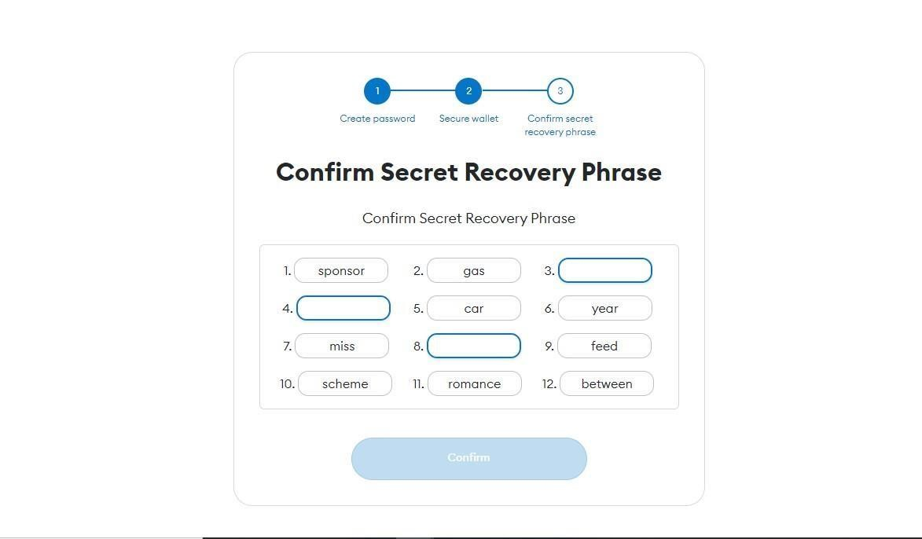

•

**Successfully completed**

